Errata

Family Law: Practice and Procedure, 7th Edition

Note: As of February 11, 2026, ebooks purchased through emond.ca, VitalSource, or Campus eBookstore will have this correction made. For ebooks purchased before this date, the Emond Bookshelf platform should have the ebook updated automatically. If you do not see the change in your ebook or are using the app offline, connect to the Internet and click the "Refresh" button at the top right of the Bookshelf app or go to Tools > Update Library to update the ebooks in your library.

Books reprinted with this change will have a line reading “Reprinted [MONTH] 2026” (or later) on the copyright page, directly below “Printed in Canada.”

February 11, 2026

- Chapter 8, p. 106 (the correction highlighted in orange):

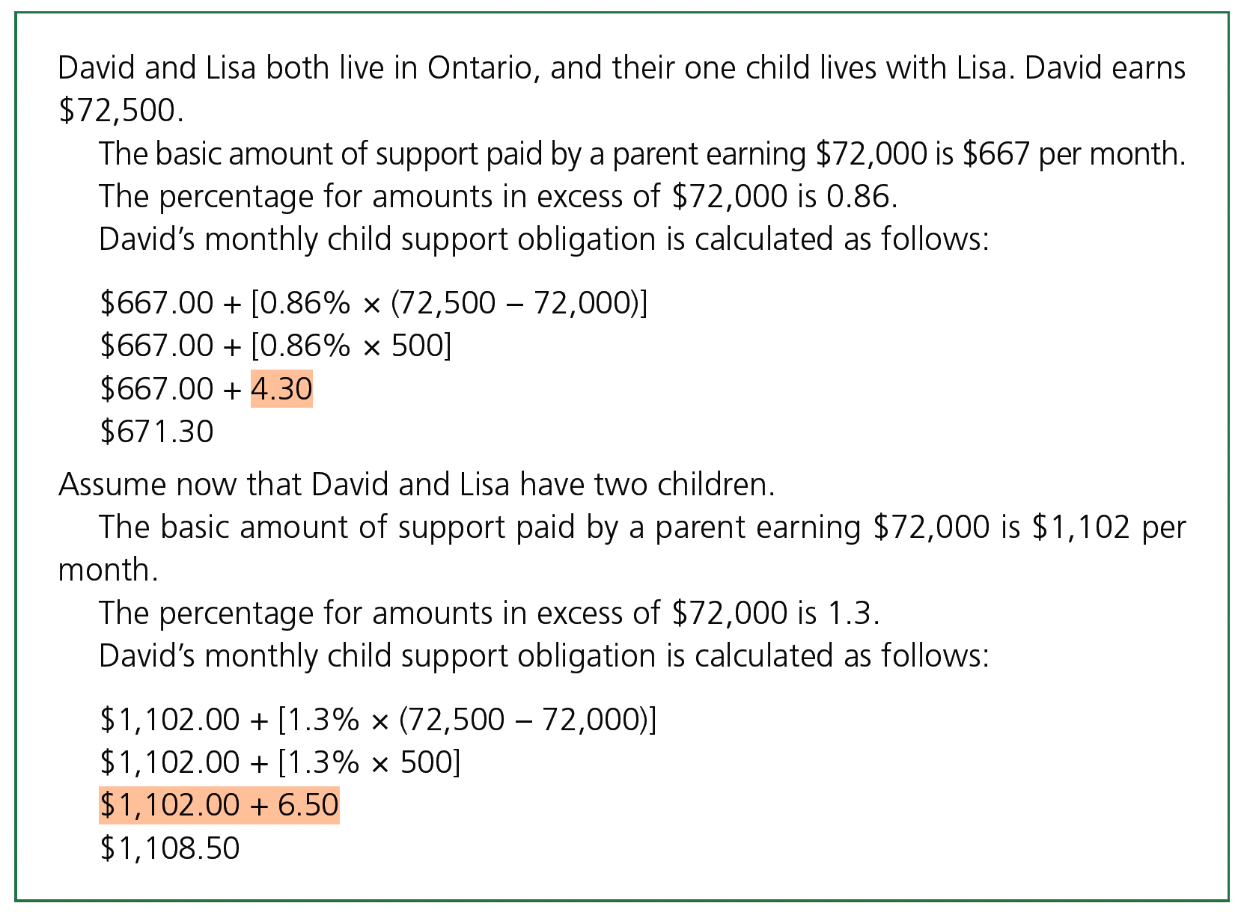

- Chapter 8, p. 111 (the correction highlighted in orange):
