Errata

Legal Accounting, 3rd Edition

Note: As of March 11, 2026, ebooks purchased through emond.ca, VitalSource, or Campus eBookstore will have this correction made. For ebooks purchased before this date, the Emond Bookshelf platform should have the ebook updated automatically. If you do not see the change in your ebook or are using the app offline, connect to the Internet and click the "Refresh" button at the top right of the Bookshelf app or go to Tools > Update Library to update the ebooks in your library.

Books reprinted with this change will have a line reading “Reprinted [MONTH] 2026” on the copyright page, directly below “Printed in Canada.”

March 11, 2026

- Page 24, Figure 2.1: The right column should say "Example," not “Normal Balance.”
- Page 64, Practice Exercise 3.2:
  - The starting balance on the T-Account for General Bank Account under Dr. should be $8,000 rather than $13,000; otherwise, the numbers do not balance.
  - The 5,000 under Withdrawals should be deleted as there should be no opening balance in withdrawals. The 5,000 comes from the first transaction, not from an opening balance.
  - Corrected Exercise 3.2:

- Page 93, Figure 3.7: Please see the changes in image below:

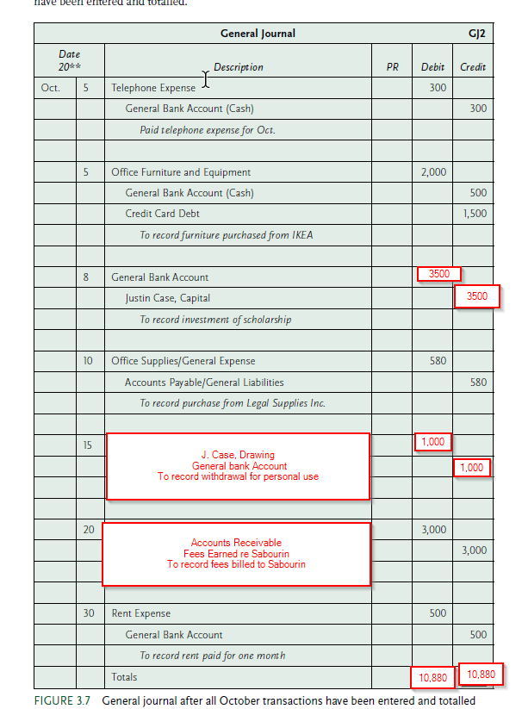

- Pages 90-92, Figure 4.3: Non-opening entries (highlighted in images below) should be removed.

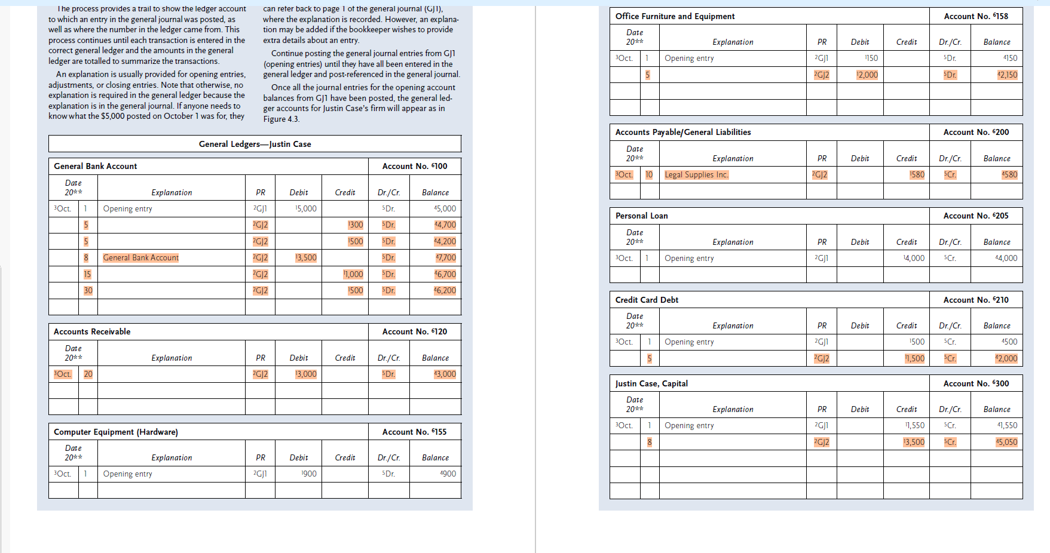

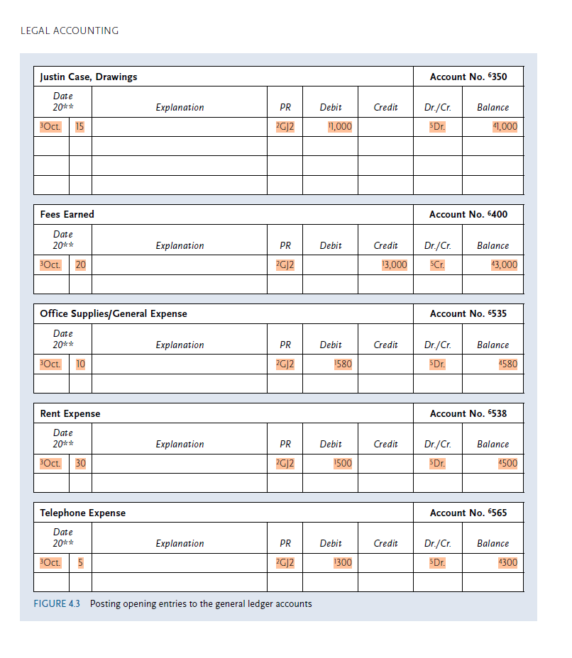
- Page 210, Figure 7.4: In the November 20 entry in the “Trust Disbursement Journal,” the “Method of Payment” column should be “Chq. #3,” not “Chq. #2”
- Page 225: Under Worksheet c, in the General Ledger Accounts, Trust Funds Owed, Account 215, the first line should be “May 30, Opening Balance, Credit 5,500.”
- Page 229: The Disbursements Journal should be “Trust Disbursements Journal.”
- Pages 259-260, Figure 8.6: Please see the Excel sheet with the correct numbers.
- Page 328, Figure 10.16: “Unexpected balances” should be “unexpended balances.”

