Errata

Police Powers, 3rd Edition

Note: As of September 21, 2026, ebooks purchased through emond.ca, VitalSource, or Campus eBookstore will have this correction made. For ebooks purchased before this date, the Emond Bookshelf platform should have the ebook updated automatically. If you do not see the change in your ebook or are using the app offline, connect to the Internet and click the "Refresh" button at the top right of the Bookshelf app or go to Tools > Update Library to update the ebooks in your library.
Books reprinted with this change will have a line reading “Reprinted [MONTH]” on the copyright page, directly below “Printed in Canada.”

CHANGES (as of September 21, 2026):
- Chapter 2, p. 33, Table 2.2: In the column "Summary Conviction,” certain offences are incorrectly labelled as summary conviction offences when they are actually dual procedure (hybrid) offences. The following offences have now been moved to the “Dual Procedure (Hybrid)” column (please also see screenshot below):
  - Indecent telephone calls, s. 372 (2) (now called "Indecent Communications")
  - Harassing phone calls, s. 372 (3) (now called "Harassing Communications")
  - Breach of recognizance, s. 811
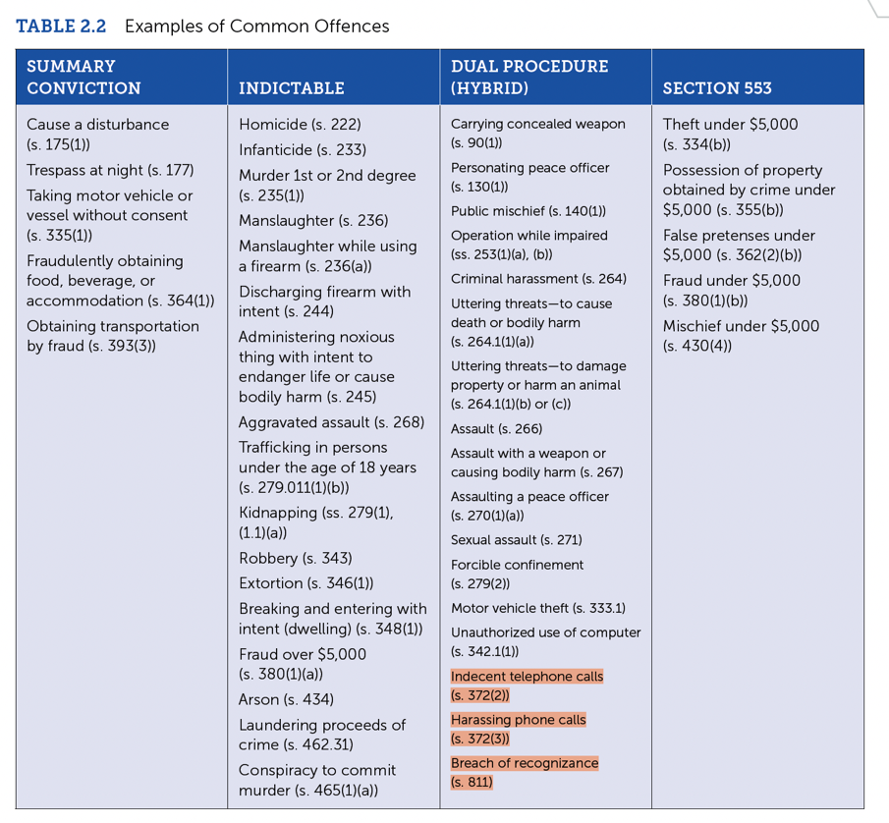
- Chapter 5, pp. 123 and 125 refer to Form 12 (Undertaking), but they should refer to Form 10. (The appendix to Chapter 5 correctly refers to it as Form 10 [pp. 142-44].)

